Exercise 01: Display The output (Html with inline CSS)
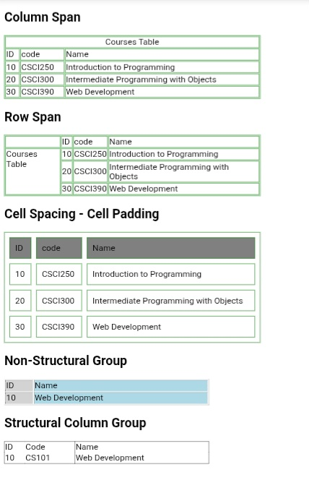
<!DOCTYPE html>
<html>
<head>
<title>Tables Example</title>
</head>
<body style="font-family:Arial,sans-serif;">
<h1>Column Span</h1>
<table border="1" style="border-collapse:collapse;border:2px solid green;width:800px;">
<tr>
<th colspan="3" style="border:2px solid green;padding:8px;">Courses Table</th>
</tr>
<tr>
<th style="border:2px solid green;padding:8px;">ID</th>
<th style="border:2px solid green;padding:8px;">code</th>
<th style="border:2px solid green;padding:8px;">Name</th>
</tr>
<tr>
<td style="border:2px solid green;padding:8px;">10</td>
<td style="border:2px solid green;padding:8px;">CSCI250</td>
<td style="border:2px solid green;padding:8px;">Introduction to Programming</td>
</tr>
<tr>
<td style="border:2px solid green;padding:8px;">20</td>
<td style="border:2px solid green;padding:8px;">CSCI300</td>
<td style="border:2px solid green;padding:8px;">Intermediate Programming with Objects</td>
</tr>
<tr>
<td style="border:2px solid green;padding:8px;">30</td>
<td style="border:2px solid green;padding:8px;">CSCI390</td>
<td style="border:2px solid green;padding:8px;">Web Development</td>
</tr>
</table>
<br><br>
<h1>Row Span</h1>
<table border="1" style="border-collapse:collapse;border:2px solid green;width:800px;">
<tr>
<td rowspan="4" style="border:2px solid green;padding:8px;width:150px;vertical-align:top;">
Courses<br>Table
</td>
<th style="border:2px solid green;padding:8px;">ID</th>
<th style="border:2px solid green;padding:8px;">code</th>
<th style="border:2px solid green;padding:8px;">Name</th>
</tr>
<tr>
<td style="border:2px solid green;padding:8px;">10</td>
<td style="border:2px solid green;padding:8px;">CSCI250</td>
<td style="border:2px solid green;padding:8px;">Introduction to Programming</td>
</tr>
<tr>
<td style="border:2px solid green;padding:8px;">20</td>
<td style="border:2px solid green;padding:8px;">CSCI300</td>
<td style="border:2px solid green;padding:8px;">Intermediate Programming with Objects</td>
</tr>
<tr>
<td style="border:2px solid green;padding:8px;">30</td>
<td style="border:2px solid green;padding:8px;">CSCI390</td>
<td style="border:2px solid green;padding:8px;">Web Development</td>
</tr>
</table>
<br><br>
<h1>Cell Spacing - Cell Padding</h1>
<table border="1" cellspacing="15" cellpadding="15" style="border:2px solid green;width:800px;">
<tr style="background:gray;">
<th>ID</th>
<th>code</th>
<th>Name</th>
</tr>
<tr>
<td>10</td>
<td>CSCI250</td>
<td>Introduction to Programming</td>
</tr>
<tr>
<td>20</td>
<td>CSCI300</td>
<td>Intermediate Programming with Objects</td>
</tr>
<tr>
<td>30</td>
<td>CSCI390</td>
<td>Web Development</td>
</tr>
</table>
<br><br>
<h1>Non-Structural Group</h1>
<table border="1” style="border-collapse:collapse;width:640px;">
<colgroup>
<col style="background:#dddddd;">
<col style="background:#bfe8ff;">
</colgroup>
<tr>
<th style="padding:8px;">ID</th>
<th style="padding:8px;">Name</th>
</tr>
<tr>
<td style="padding:8px;">10</td>
<td style="padding:8px;">Web Development</td>
</tr>
</table>
<br><br>
<h1>Structural Column Group</h1>
<table border="1"
style="border-collapse:collapse;width:640px;">
<colgroup span="2"></colgroup>
<colgroup></colgroup>
<tr>
<th style="padding:8px;">ID</th>
<th style="padding:8px;">Code</th>
<th style="padding:8px;">Name</th>
</tr>
<tr>
<td style="padding:8px;">10</td>
<td style="padding:8px;">CS101</td>
<td style="padding:8px;">Web Development</td>
</tr>
</table>
</body>
</html>

Exercise 02 : Display This Output (Html)

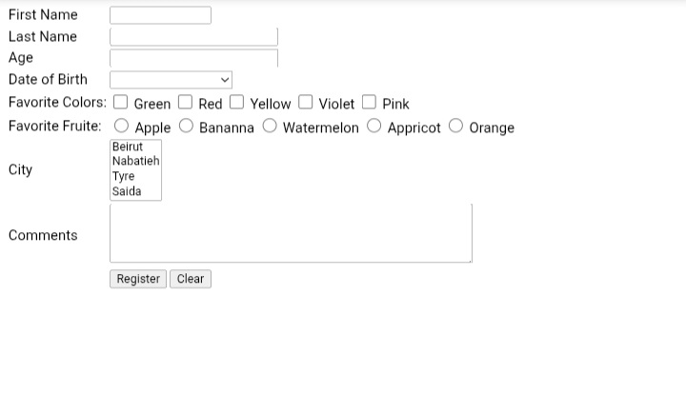

<!DOCTYPE html>
<html>
<head>
<title>Registration Form</title>
</head>
<body style="font-family:Arial; font-size:20px;">
<form>
<table>
<tr>
<td style="padding:8px;">First Name</td>
<td><input type="text" style="width:220px;"></td>
</tr>
<tr>
<td style="padding:8px;">Last Name</td>
<td><input type="text" style="width:380px;"></td>
</tr>
<tr>
<td style="padding:8px;">Age</td>
<td><input type="number" style="width:380px;"></td>
</tr>
<tr>
<td style="padding:8px;">Date of Birth</td>
<td>
<select style="width:280px;">
<option></option>
<option>01/01/2000</option>
<option>02/02/2001</option>
<option>03/03/2002</option>
</select>
</td>
</tr>
<tr>
<td style="padding:8px;">Favorite Colors:</td>
<td>
<input type="checkbox"> Green
<input type="checkbox"> Red
<input type="checkbox"> Yellow
<input type="checkbox"> Violet
<input type="checkbox"> Pink
</td>
</tr>
<tr>
<td style="padding:8px;">Favorite Fruite:</td>
<td>
<input type="radio" name="fruit"> Apple
<input type="radio" name="fruit"> Bananna
<input type="radio" name="fruit"> Watermelon
<input type="radio" name="fruit"> Appricot
<input type="radio" name="fruit"> Orange
</td>
</tr>
<tr>
<td style="padding:8px;">City</td>
<td>
<select size="4" style="width:120px;">
<option>Beirut</option>
<option>Nabatieh</option>
<option>Tyre</option>
<option>Saida</option>
</select>
</td>
</tr>
<tr>
<td style="padding:8px; vertical-align:top;">Comments</td>
<td>
<textarea rows="6" cols="65"></textarea>
</td>
</tr>
<tr>
<td></td>
<td>
<input type="submit" value="Register">
<input type="reset" value="Clear">
</td>
</tr>
</table>
</form>
</body>
</html>

Exercise 03 : Display The Output (Html)
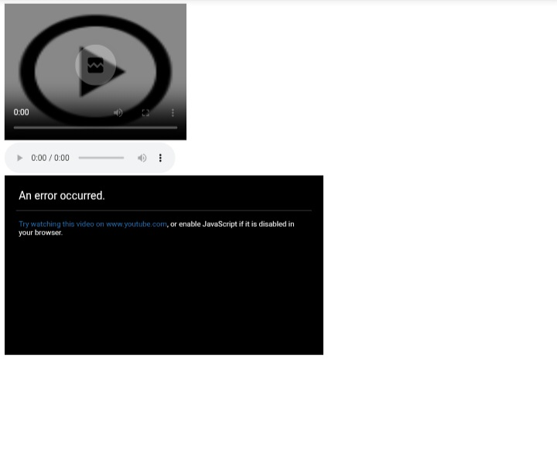

<!DOCTYPE html>
<html lang="en">
<head>
<meta charset="UTF-8">
<meta name="viewport" content="width=device-width, initial-scale=1.0">
<title>Media Example</title>
<style>
body{
font-family: Arial, sans-serif;
background:#fff;
padding:10px;
}
video{
width:450px;
display:block;
margin-bottom:15px;
}
audio{
width:420px;
display:block;
margin-bottom:20px;
}
iframe{
width:780px;
height:440px;
border:none;
}
</style>
</head>
<body>
<!-- Video -->
<video controls poster="https://via.placeholder.com/450x330">
<source src="video.mp4" type="video/mp4">
Your browser does not support the video tag.
</video>
<!-- Audio -->
<audio controls>
<source src="audio.mp3" type="audio/mpeg">
Your browser does not support the audio element.
</audio>
<!-- YouTube Embed -->
<iframe src="https://www.youtube.com/embed/INVALID_VIDEO_ID" allowfullscreen>
</iframe>
</body>
</html>

Exercise 04 : Write the Output (Html and CSS)
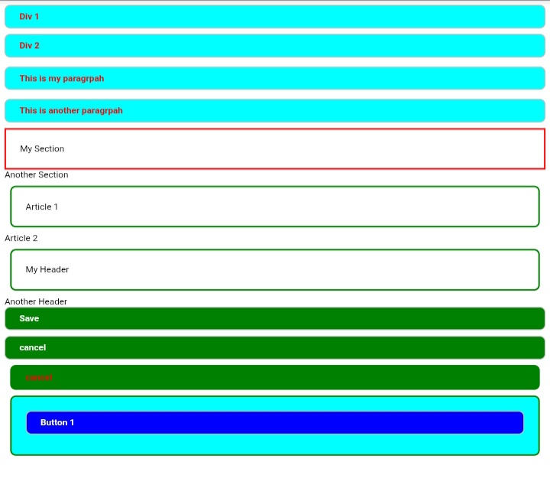
testo4.html:
<!DOCTYPE html>
<html lang="en">
<head>
<meta charset="UTF-8">
<meta name="viewport" content="width=device-width, initial-scale=1.0">
<title>Layout Example</title>
<link rel="stylesheet" href="testo4.css">
</head>
<body>
<div class="box">Div 1</div>
<div class="box">Div 2</div>
<p class="box">This is my paragraph</p>
<p class="box">This is another paragraph</p>
<section class="section-red">
<h2>My Section</h2>
</section>
<section>
<h2>Another Section</h2>
</section>
<article class="article-box">
<h2>Article 1</h2>
</article>
<article>
<h2>Article 2</h2>
</article>
<header class="article-box">
<h2>My Header</h2>
</header>
<header>
<h2>Another Header</h2>
</header>
<button class="green-btn">Save</button>
<button class="green-btn">cancel</button>
<button class="green-btn red-text">cancel</button>
<div class="button-container">
<button class="blue-btn">Button 1</button>
</div>
</body>
</html>

testo4.css:
body{
font-family: Arial, sans-serif;
margin:10px;
}
.box{
background:#19dbe2;
padding:18px;
margin:12px 0;
border-radius:10px;
font-size:22px;
font-weight:bold;
}
.section-red{
border:4px solid red;
padding:20px;
margin:12px 0;
}
.article-box{
border:4px solid green;
border-radius:15px;
padding:25px;
margin:12px;
}
.green-btn{
width:100%;
background:green;
color:white;
border:none;
padding:18px;
margin:12px 0;
border-radius:10px;
font-size:22px;
font-weight:bold;
cursor:pointer;
}
.red-text{
color:red;
}
.button-container{
background:#19dbe2;
border:4px solid green;
border-radius:12px;
padding:35px;
margin-top:15px;
}
.blue-btn{
width:100%;
background:blue;
color:white;
border:none;
border-radius:12px;
padding:18px;
font-size:22px;
font-weight:bold;
cursor:pointer;
}

Exercise 05: Display The Output (Html / CSS / JavaScript)
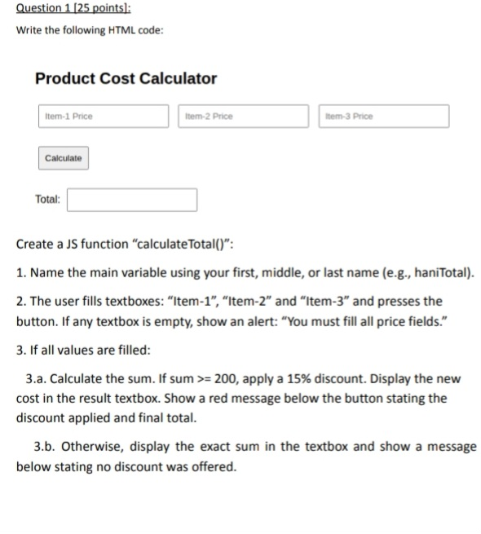
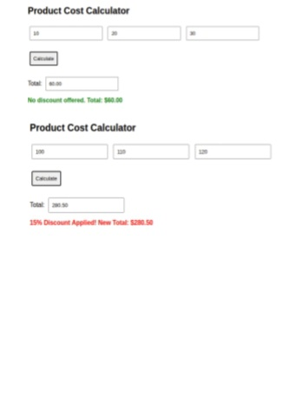
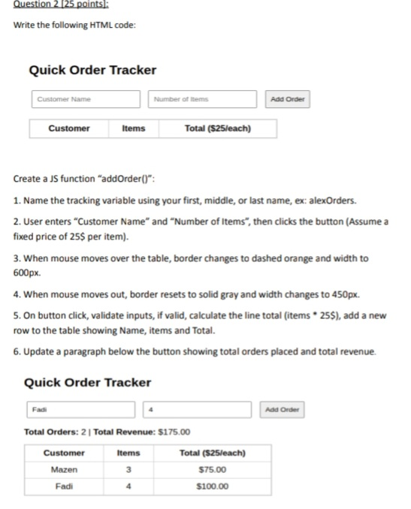

question 1:
<!DOCTYPE html>
<html>
<head>
<meta charset="UTF-8">
<title>Product Cost Calculator</title>
<style>
body{
font-family: Arial;
margin:40px;
}
input{
width:180px;
padding:10px;
margin:10px;
}
button{
padding:10px 20px;
margin:10px;
}
#msg{
font-size:20px;
font-weight:bold;
}
</style>
<script>
function calculateTotal(){
let jawadTotal = 0;
let item1 = document.getElementById("item1").value;
let item2 = document.getElementById("item2").value;
let item3 = document.getElementById("item3").value;
if(item1=="" || item2=="" || item3==""){
alert("You must fill all price fields.");
return;
}
jawadTotal = Number(item1)+Number(item2)+Number(item3);
if(jawadTotal>=200){
jawadTotal = jawadTotal*0.85;
document.getElementById("total").value=jawadTotal.toFixed(2);
document.getElementById("msg").style.color="red";
document.getElementById("msg").innerHTML=
"15% Discount Applied! New Total: $" + jawadTotal.toFixed(2);
}
else{
document.getElementById("total").value=jawadTotal.toFixed(2);
document.getElementById("msg").style.color="green";
document.getElementById("msg").innerHTML=
"No discount offered. Total: $" + jawadTotal.toFixed(2);
}
}
</script>
</head>
<body>
<h1>Product Cost Calculator</h1>
<input type="text" id="item1" placeholder="Item-1 Price">
<input type="text" id="item2" placeholder="Item-2 Price">
<input type="text" id="item3" placeholder="Item-3 Price">
<br><br>
<button onclick="calculateTotal()">Calculate</button>
<br><br>
<label>Total:</label>
<input type="text" id="total" readonly>
<p id="msg"></p>
</body>
</html>

question 2:
<!DOCTYPE html>
<html>
<head>
<meta charset="UTF-8">
<title>Quick Order Tracker</title>
<style>
body{
font-family:Arial;
margin:40px;
}
input{
padding:10px;
width:200px;
margin:10px;
}
button{
padding:10px 20px;
}
table{
width:450px;
border-collapse:collapse;
border:2px solid gray;
}
th,td{
border:1px solid gray;
padding:10px;
text-align:center;
}
</style>
<script>
let jawadOrders = 0;
let totalRevenue = 0;
function addOrder(){
let name=document.getElementById("name").value;
let items=document.getElementById("items").value;
if(name=="" || items==""){
alert("Fill all fields");
return;
}
let total=Number(items)*25;
jawadOrders++;
totalRevenue+=total;
let table=document.getElementById("orders");
let row=table.insertRow(-1);
row.insertCell(0).innerHTML=name;
row.insertCell(1).innerHTML=items;
row.insertCell(2).innerHTML="$"+total.toFixed(2);
document.getElementById("info").innerHTML=
"Total Orders: "+jawadOrders+
" | Total Revenue: $"+totalRevenue.toFixed(2);
}
function mouseIn(){
let table=document.getElementById("orders");
table.style.border="3px dashed orange";
table.style.width="600px";
}
function mouseOut(){
let table=document.getElementById("orders");
table.style.border="2px solid gray";
table.style.width="450px";
}
</script>
</head>
<body>
<h1>Quick Order Tracker</h1>
<input type="text" id="name" placeholder="Customer Name">
<input type="number" id="items" placeholder="Number of Items">
<button onclick="addOrder()">Add Order</button>
<p id="info">
Total Orders: 0 | Total Revenue: $0.00
</p>
<table id="orders" onmouseover="mouseIn()" onmouseout="mouseOut()">
<tr>
<th>Customer</th>
<th>Items</th>
<th>Total ($25/each)</th>
</tr>
</table>
</body>
</html>

Exercise 06 : React
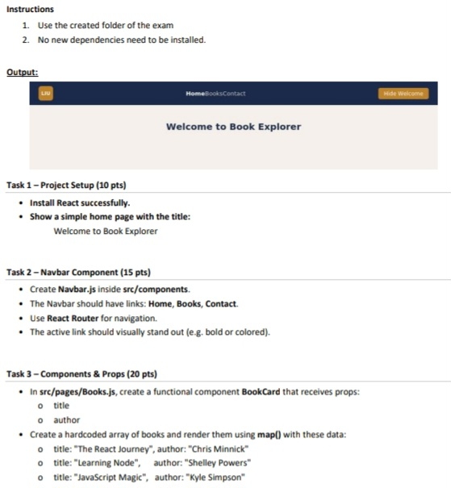

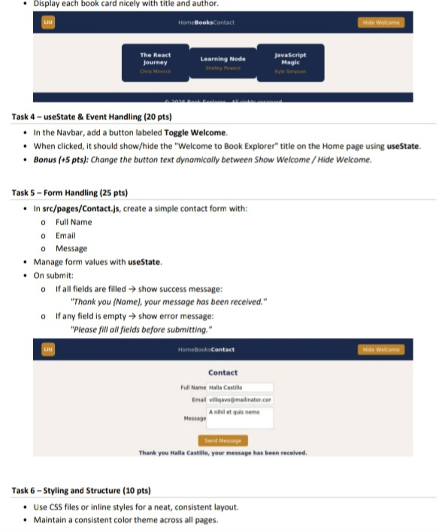

File Structure:
book-explorer/
├── src/
│ ├── components/
│ │ ├── Navbar.js
│ │ └── Navbar.css
│ ├── pages/
│ │ ├── Home.jxs
│ │ ├── Books.xjs
│ │ ├── Contact.jsx
│ │ ├── Home.css
│ │ ├── Books.css
│ │ └── Contact.css
│ ├── App.js
│ ├── App.css
│ ├── index.js
│ └── index.css
├── package.json

package.json:
{
"name": "book-explorer",
"version": "1.0.0",
"private": true,
"dependencies": {
"react": "^18.2.0",
"react-dom": "^18.2.0",
"react-router-dom": "^6.22.3",
"react-scripts": "5.0.1"
},
"scripts": {
"start": "react-scripts start",
"build": "react-scripts build"
}
}

src/index.js:
import React from "react";
import ReactDOM from "react-dom/client";
import { BrowserRouter } from "react-router-dom";
import App from "./App";
import "./index.css";
const root = ReactDOM.createRoot(document.getElementById("root"));
root.render(
<BrowserRouter>
<App />
</BrowserRouter>
);

App.jsx:
import { Routes, Route } from "react-router-dom";
import { useState } from "react";
import Navbar from "./components/Navbar";
import Home from "./pages/Home";
import Books from "./pages/Books";
import Contact from "./pages/Contact";
import "./App.css";
function App() {
const [showWelcome, setShowWelcome] = useState(true);
return (
<>
<Navbar
showWelcome={showWelcome}
setShowWelcome={setShowWelcome}
/>
<Routes>
<Route
path="/"
element={<Home showWelcome={showWelcome} />}
/>
<Route path="/books" element={<Books />} />
<Route path="/contact" element={<Contact />} />
</Routes>
</>
);
}
export default App;

Navbar.jsx:
import { NavLink } from "react-router-dom";
import "./Navbar.css";
function Navbar({ showWelcome, setShowWelcome }) {
return (
<nav className="navbar">
<NavLink
to="/"
className={({ isActive }) => (isActive ? "active" : "")}
>
Home
</NavLink>
<NavLink
to="/books"
className={({ isActive }) => (isActive ? "active" : "")}
>
Books
</NavLink>
<NavLink
to="/contact"
className={({ isActive }) => (isActive ? "active" : "")}
>
Contact
</NavLink>
<button onClick={() => setShowWelcome(!showWelcome)}>
{showWelcome ? "Hide Welcome" : "Show Welcome"}
</button>
</nav>
);
}
export default Navbar;

Home.jsx:
import "./Home.css";
function Home({ showWelcome }) {
return (
<div className="container">
{showWelcome && <h1>Welcome to Book Explorer</h1>}
</div>
);
}
export default Home;

Books.jsx:
import "./Books.css";
function BookCard({ title, author }) {
return (
<div className="card">
<h2>{title}</h2>
<p>{author}</p>
</div>
);
}
function Books() {
const books = [
{
title: "The React Journey",
author: "Chris Minnick"
},
{
title: "Learning Node",
author: "Shelley Powers"
},
{
title: "JavaScript Magic",
author: "Kyle Simpson"
}
];
return (
<div className="container">
<h1>Books</h1>
{books.map((book, index) => (
<BookCard
key={index}
title={book.title}
author={book.author}
/>
))}
</div>
);
}
export default Books;

Contact.jsx:
import { useState } from "react";
import "./Contact.css";
function Contact() {
const [fullName, setFullName] = useState("");
const [email, setEmail] = useState("");
const [message, setMessage] = useState("");
const [result, setResult] = useState("");
const handleSubmit = (e) => {
e.preventDefault();
if (fullName && email && message) {
setResult(
`Thank you ${fullName}, your message has been received.`
);
} else {
setResult(
"Please fill all fields before submitting."
);
}
};
return (
<div className="container">
<h1>Contact</h1>
<form onSubmit={handleSubmit}>
<input
type="text"
placeholder="Full Name"
value={fullName}
onChange={(e) => setFullName(e.target.value)}
/>
<input
type="email"
placeholder="Email"
value={email}
onChange={(e) => setEmail(e.target.value)}
/>
<textarea
placeholder="Message"
value={message}
onChange={(e) => setMessage(e.target.value)}
/>
<button type="submit">
Submit
</button>
</form>
<p>{result}</p>
</div>
);
}
export default Contact;

Navbar.css:
.navbar{
background:#1e3a8a;
padding:15px;
display:flex;
gap:20px;
align-items:center;
}
.navbar a{
color:white;
text-decoration:none;
}
.active{
font-weight:bold;
color:yellow;
}
button{
margin-left:auto;
padding:8px 15px;
}
src/pages/Home.css
.container{
text-align:center;
padding:30px;
}

Books.css:
.container{
padding:30px;
}
.card{
border:1px solid #ccc;
padding:15px;
margin:15px 0;
border-radius:8px;
}

Contact.css:
.container{
padding:30px;
}
form{
display:flex;
flex-direction:column;
gap:15px;
width:350px;
}
input,
textarea{
padding:10px;
}
button{
width:150px;
}

App.css:
body{
margin:0;
font-family:Arial, sans-serif;
background:#f4f4f4;
}

index.css:
*{
margin:0;
padding:0;
box-sizing:border-box;
}

Exercise 07 : Build a Responsive University Website
Create a responsive website called University Portal using HTML, CSS, and Bootstrap 5.
Part 1 – Header (20 Marks):
Create a responsive Bootstrap Navbar.
Add the website logo "University Portal".
Add the following navigation links:
Home
Courses
Teachers
Contact
Include a Bootstrap Search Form on the right.
The Navbar should collapse into a hamburger menu on small screens.

Part 2 – Hero Section (20 Marks):
Create a Hero section using Bootstrap.
Requirements:
Large heading: Welcome to University Portal
Short paragraph describing the website.
Two Bootstrap buttons:
Explore Courses
Contact Us
Add an image beside the text using the Bootstrap Grid System.

Part 3 – Courses Section (20 Marks):
Create a section titled Our Courses.
Display 6 Bootstrap Cards.
Each card should contain:
Course Image
Course Name
Short Description
Bootstrap "Read More" Button
Arrange the cards using the Bootstrap Grid System so they are responsive.

Part 4 – Statistics Section (10 Marks):
Create a Bootstrap section displaying:
2500+ Students
120 Teachers
75 Courses
15 Years Experience
Use Bootstrap Columns.

Part 5 – Contact Form (20 Marks):
Create a Bootstrap Form that contains:
Full Name
Email
Phone Number
Subject
Message
Submit Button
Use Bootstrap Form Controls and proper spacing.

Part 6 – Footer (10 Marks):
Create a Bootstrap Footer containing:
Copyright © 2026 University Portal
Facebook icon
Instagram icon
Twitter icon
LinkedIn icon
Use Bootstrap Icons and align everything in the center.

index.html :
<!DOCTYPE html>
<html lang="en">
<head>
<meta charset="UTF-8">
<meta name="viewport" content="width=device-width, initial-scale=1.0">
<title>University Portal</title>
<link href="https://cdn.jsdelivr.net/npm/bootstrap@5.3.3/dist/css/bootstrap.min.css" rel="stylesheet">
<link rel="stylesheet" href="style.css">
<link rel="stylesheet" href="https://cdn.jsdelivr.net/npm/bootstrap-icons@1.11.3/font/bootstrap-icons.min.css">
</head>
<body>
<nav class="navbar navbar-expand-lg navbar-dark bg-dark">
<div class="container">
<a class="navbar-brand" href="#"> University Portal </a>
<button class="navbar-toggler" type="button" data-bs-toggle="collapse" data-bs-target="#menu">
<span class="navbar-toggler-icon"></span>
</button>
<div class="collapse navbar-collapse" id="menu">
<ul class="navbar-nav ms-auto">
<li class="nav-item">
<a class="nav-link" href="#">Home</a>
</li>
<li class="nav-item">
<a class="nav-link" href="#">Courses</a>
</li>
<li class="nav-item">
<a class="nav-link" href="#">Teachers</a>
</li>
<li class="nav-item">
<a class="nav-link" href="#">Contact</a>
</li>
</ul>
<form class="d-flex ms-3">
<input class="form-control me-2" type="search" placeholder="Search">
<button class="btn btn-primary"> Search </button>
</form>
</div>
</div>
</nav>
<section class="container mt-5">
<div class="row align-items-center">
<div class="col-md-6">
<h1>Welcome to University Portal</h1>
<p>Learn programming, web development, AI, networking and many other courses. </p>
<button class="btn btn-primary"> Explore Courses </button>
<button class="btn btn-outline-dark"> Contact Us </button>
</div>
<div class="col-md-6"> <img src="university.jpg" class="img-fluid rounded"> </div>
</div>
</section>
<section class="container mt-5">
<h2 class="text-center mb-4"> Our Courses </h2>
<div class="row">
<div class="col-md-4 mb-4">
<div class="card h-100">
<img src="course1.jpg" class="card-img-top">
<div class="card-body">
<h5 class="card-title"> Web Development </h5>
<p class="card-text"> Learn HTML, CSS, JavaScript and Bootstrap. </p>
<a href="#" class="btn btn-primary"> Read More </a>
</div>
</div>
</div>
<div class="col-md-4 mb-4">
<div class="card h-100">
<img src="course2.jpg" class="card-img-top">
<div class="card-body">
<h5 class="card-title"> Python </h5>
<p class="card-text"> Programming with Python from beginner to advanced. </p>
<a href="#" class="btn btn-primary"> Read More </a>
</div>
</div>
</div>
<div class="col-md-4 mb-4">
<div class="card h-100">
<img src="course3.jpg" class="card-img-top">
<div class="card-body">
<h5 class="card-title"> Artificial Intelligence </h5>
<p class="card-text"> Introduction to AI and Machine Learning. </p>
<a href="#" class="btn btn-primary"> Read More </a>
</div>
</div>
</div>
<div class="col-md-4 mb-4">
<div class="card h-100">
<img src="course4.jpg" class="card-img-top">
<div class="card-body">
<h5 class="card-title"> Networking </h5>
<p class="card-text"> Learn computer networking fundamentals. </p>
<a href="#" class="btn btn-primary"> Read More </a>
</div>
</div>
</div>
<div class="col-md-4 mb-4">
<div class="card h-100">
<img src="course5.jpg" class="card-img-top">
<div class="card-body">
<h5 class="card-title"> Database </h5>
<p class="card-text"> Learn SQL and database management. </p>
<a href="#" class="btn btn-primary"> Read More </a>
</div>
</div>
</div>
<div class="col-md-4 mb-4">
<div class="card h-100">
<img src="course6.jpg" class="card-img-top">
<div class="card-body">
<h5 class="card-title"> Cyber Security </h5>
<p class="card-text"> Protect systems and networks from attacks. </p>
<a href="#" class="btn btn-primary"> Read More </a>
</div>
</div>
</div>
</div>
</section>
<section class="container text-center mt-5">
<div class="row">
<div class="col-md-3">
<h2>2500+</h2>
<p>Students</p>
</div>
<div class="col-md-3">
<h2>120</h2>
<p>Teachers</p>
</div>
<div class="col-md-3">
<h2>75</h2>
<p>Courses</p>
</div>
<div class="col-md-3">
<h2>15</h2>
<p>Years Experience</p>
</div>
</div>
</section>
<section class="container mt-5 mb-5">
<h2 class="text-center mb-4"> Contact Us </h2>
<form>
<div class="row">
<div class="col-md-6 mb-3">
<input type="text" class="form-control" placeholder="Full Name">
</div>
<div class="col-md-6 mb-3">
<input type="email" class="form-control" placeholder="Email">
</div>
</div>
<div class="row">
<div class="col-md-6 mb-3">
<input
type="text" class="form-control" placeholder="Phone Number">
</div>
<div class="col-md-6 mb-3">
<input type="text" class="form-control" placeholder="Subject">
</div>
</div>
<div class="mb-3">
<textarea class="form-control" rows="5" placeholder="Message">
</textarea>
</div>
<button class="btn btn-success"> Submit </button>
</form>
</section>
<footer class="bg-dark text-white text-center p-4">
<p> Copyright © 2026 University Portal </p>
<i class="bi bi-facebook fs-3 m-2"></i>
<i class="bi bi-instagram fs-3 m-2"></i>
<i class="bi bi-twitter fs-3 m-2"></i>
<i class="bi bi-linkedin fs-3 m-2"></i>
</footer>
<script src="https://cdn.jsdelivr.net/npm/bootstrap@5.3.3/dist/js/bootstrap.bundle.min.js"></script>
</body>
</html>

style.css:
body{
background:#f8f9fa;
}
h1,h2{
font-weight:bold;
}
.navbar-brand{
font-size:28px;
font-weight:bold;
}
.card{
transition:0.3s;
}
.card:hover{
transform:scale(1.05);
box-shadow:0 0 15px gray;
}
.card img{
height:220px;
object-fit:cover;
}
.btn{
margin-top:10px;
}
footer i{
cursor:pointer;
transition:0.3s;
}
footer i:hover{
color:gold;
}
section{
padding-top:30px;
padding-bottom:30px;
}
textarea{
resize:none;
}

Exercise 08 :PhP
Create a simple Book Order website connected to a PHP backend.

Task 1 (10 Marks):
Create an HTML page named index.html that contains a form with the following fields:
Customer Name
Email
Book Title
Quantity
Submit Button
The form must send data to order.php using the POST method.

Task 2 (20 Marks):
Create order.php that:
Receives the submitted data.
Stores the values into PHP variables.
Displays all submitted information.

Task 3 (20 Marks):
Validate the form:
If any field is empty, display:
Please fill all fields.
Otherwise continue.

Task 4 (20 Marks):
Calculate the total price.
Book price:
£15
Formula:
Total = Quantity × 15
Display the total price.

Task 5 (15 Marks):
If Quantity is greater than or equal to 3, display:
You received a 10% discount.
Also display the final price after discount.

Task 6 (15 Marks):
Use CSS to make the form look clean and centred.

<!DOCTYPE html>
<html>
<head>
<!DOCTYPE html>
<html>
<head>
<title>Book Order</title>
<link rel="stylesheet" href="style.css">
</head>
<body>
<div class="container">
<h1>Book Order Form</h1>
<form action="order.php" method="POST">
<input type="text" name="name" placeholder="Customer Name">
<input type="email" name="email" placeholder="Email">
<input type="text" name="book" placeholder="Book Title">
<input type="number" name="quantity" placeholder="Quantity">
<button type="submit"> Order </button>
</form>
</div>
</body>
</html>

order.php:
<?php $name = $_POST["name"]; $email = $_POST["email"]; $book = $_POST["book"];
$quantity = $_POST["quantity"];
if( empty($name) || empty($email) || empty($book) || empty($quantity) ){
echo "<h2>Please fill all fields.</h2>";
}
else{
$price = 15;
$total = $quantity * $price;
echo "<h2>Order Details</h2>";
echo "Customer Name: $name <br>";
echo "Email: $email <br>";
echo "Book Title: $book <br>";
echo "Quantity: $quantity <br>";
echo "Total Price: £$total <br>";
if($quantity >= 3){
$discount = $total * 0.10;
$finalPrice = $total - $discount;
echo "<br>";
echo "You received a 10% discount.<br>";
echo "Final Price: £$finalPrice";
}
}
?>

style.css:
body{
font-family: Arial;
background:#f2f2f2;
}
.container{
width:400px;
margin:50px auto;
background:white;
padding:20px;
border-radius:10px;
}
input{
width:100%;
padding:10px;
margin:10px 0;
}
button{
width:100%;
padding:10px;
background:green;
color:white;
border:none;
}

Exercise 09 : Node.js
Create a Student Management System using React.js, Node.js, Express.js, and MySQL.

Part 1 – Database (20 Marks):
Create a MySQL database called student_db.
Create a table called students with the following columns:
id (INT, AUTO_INCREMENT, PRIMARY KEY)
name (VARCHAR(100))
email (VARCHAR(100))
major (VARCHAR(100))
Insert at least 3 sample students into the table.

Part 2 – Backend (40 Marks):
Using Node.js and Express.js, connect your application to MySQL.
Create the following REST API endpoints:
GET /students → Return all students.
GET /students/:id → Return one student by ID.
POST /students → Add a new student.
PUT /students/:id → Update a student.
DELETE /students/:id → Delete a student.
All requests and responses should use JSON.

Part 3 – Frontend (40 Marks):
Using React.js, create a page that:
Displays all students in a table.
Includes a form to add a new student.
Allows updating an existing student.
Allows deleting a student.
Uses Axios to communicate with the backend.

Database (MySQL)
CREATE DATABASE student_db;
USE student_db;
CREATE TABLE students (
id INT AUTO_INCREMENT PRIMARY KEY,
name VARCHAR(100),
email VARCHAR(100),
major VARCHAR(100)
);
INSERT INTO students(name,email,major)
VALUES
('John Smith','john@gmail.com','Computer Science'),
('Sara Ali','sara@gmail.com','Information Technology'),
('Mike Brown','mike@gmail.com','Software Engineering');

server.js:
const express = require("express");
const mysql = require("mysql2");
const cors = require("cors");
const app = express();
app.use(cors());
app.use(express.json());
const db = mysql.createConnection({
host: "localhost",
user: "root",
password: "",
database: "student_db"
});
db.connect(err => {
if(err) throw err;
console.log("MySQL Connected");
});
app.get("/students",(req,res)=>{
db.query("SELECT * FROM students",(err,result)=>{
if(err) throw err;
res.json(result);
});
});
app.get("/students/:id",(req,res)=>{
db.query(
"SELECT * FROM students WHERE id=?",
[req.params.id],
(err,result)=>{
if(err) throw err;
res.json(result);
}
);
});
app.post("/students",(req,res)=>{
const {name,email,major}=req.body;
db.query(
"INSERT INTO students(name,email,major) VALUES(?,?,?)",
[name,email,major],
(err)=>{
if(err) throw err;
res.json({message:"Student Added"});
}
);
});
app.put("/students/:id",(req,res)=>{
const {name,email,major}=req.body;
db.query(
"UPDATE students SET name=?,email=?,major=? WHERE id=?",
[name,email,major,req.params.id],
(err)=>{
if(err) throw err;
res.json({message:"Student Updated"});
}
);
});
app.delete("/students/:id",(req,res)=>{
db.query(
"DELETE FROM students WHERE id=?",
[req.params.id],
(err)=>{
if(err) throw err;
res.json({message:"Student Deleted"});
}
);
});
app.listen(5000,()=>{
console.log("Server running on port 5000");
});

App.jsx:
import {useState,useEffect} from "react";
import axios from "axios";
function App(){
const [students,setStudents]=useState([]);
const [name,setName]=useState("");
const [email,setEmail]=useState("");
const [major,setMajor]=useState("");
useEffect(()=>{
loadStudents();
},[]);
const loadStudents=()=>{
axios.get("http://localhost:5000/students")
.then(res=>setStudents(res.data));
}
const addStudent=()=>{
axios.post("http://localhost:5000/students",{
name,email,major
}).then(()=>{
loadStudents();
});
}
const deleteStudent=(id)=>{
axios.delete(`http://localhost:5000/students/${id}`)
.then(()=>{
loadStudents();
});
}
return(
<div>
<h1>Student Management System</h1>
<input placeholder="Name" onChange={(e)=>setName(e.target.value)} />
<input placeholder="Email" onChange={(e)=>setEmail(e.target.value)} />
<input placeholder="Major" onChange={(e)=>setMajor(e.target.value)} />
<button onClick={addStudent}> Add Student </button>
<table border="1">
<thead>
<tr>
<th>ID</th>
<th>Name</th>
<th>Email</th>
<th>Major</th>
<th>Delete</th>
</tr>
</thead>
<tbody>
{
students.map(student=>(
<tr key={student.id}>
<td>{student.id}</td> <td>{student.name}</td> <td>{student.email}</td>
<td>{student.major}</td>
<td>
<button onClick={()=>deleteStudent(student.id)}> Delete </button>
</td>
</tr>
))
}
</tbody>
</table>
</div>
); }
export default App;

